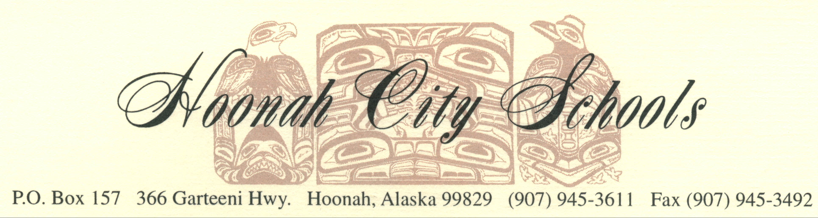

HOONAH CITY SCHOOLS BOARD OF EDUCATION

Saturday, April 15, 2017

Emergency Board Meeting
10:00 am

Room 418

CALL TO ORDER
PLEDGE OF ALLEGIANCE
ROLL CALL (ESTABLISH QUORUM)
ADOPTION OF AGENDA
PUBLIC COMMENTS (THREE-MINUTES PER SPEAKER)
EXECUTIVE SESSION: Personnel
ADJOURNMENT

